OOAD LAB EXPRIMENT

UML FOR LIBRARY MANAGEMENT SYSTEM

USE CASE DAIGRAM

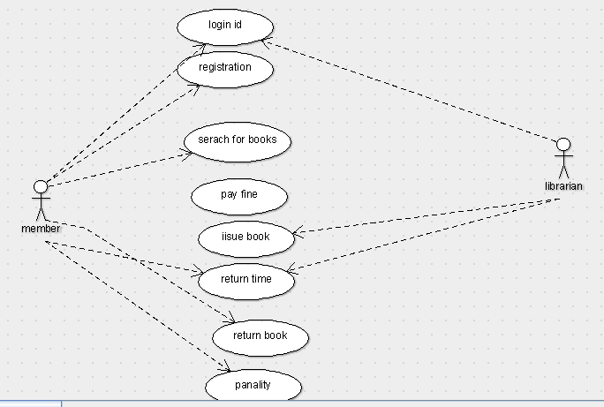

CLASS DAIGRAM

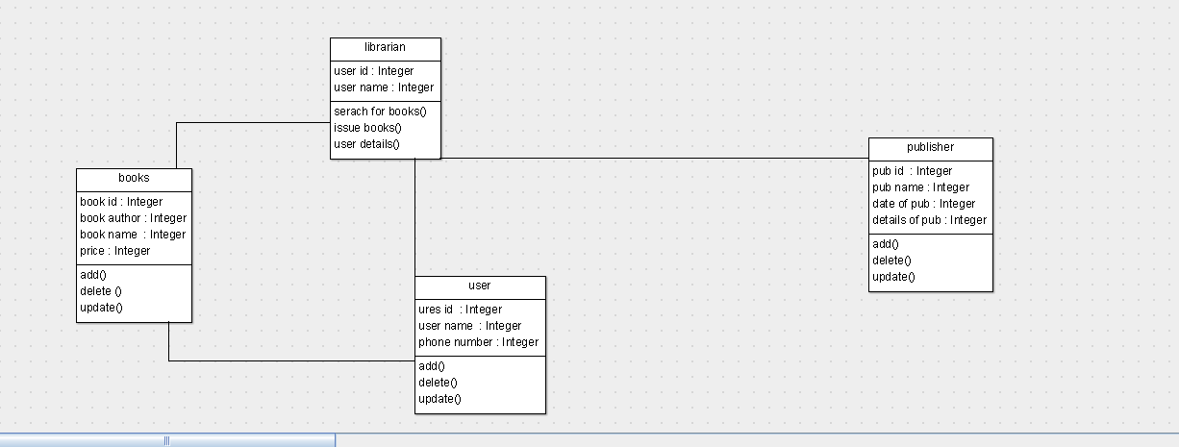

ACTIVITY DIAGRAM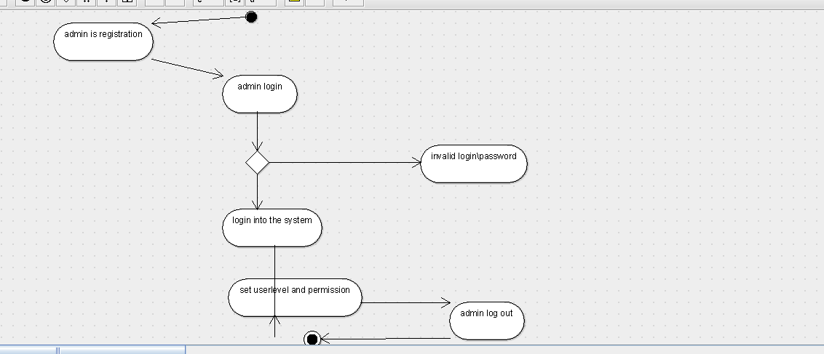

SEQUENCE DAIGRAM

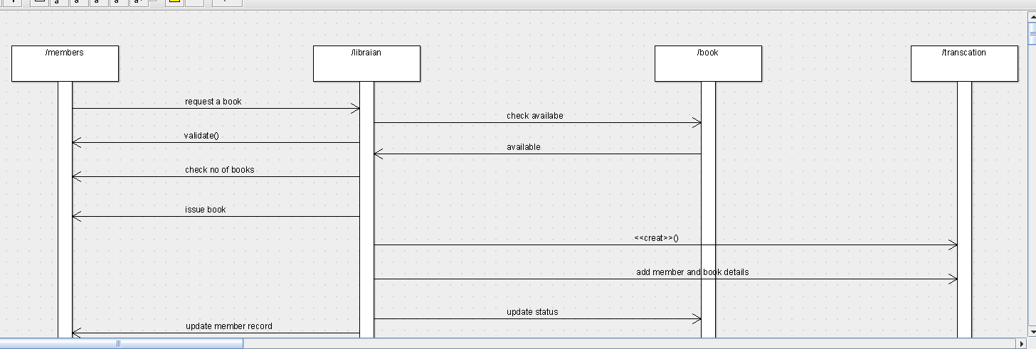

COLLABRATION DIAGRAM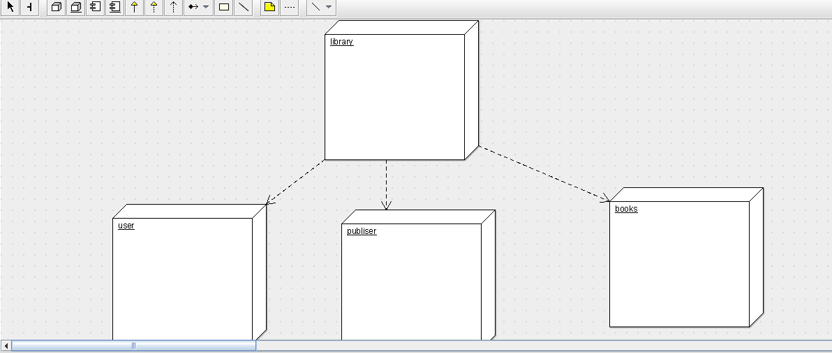

STATE CHART DAIGRAM

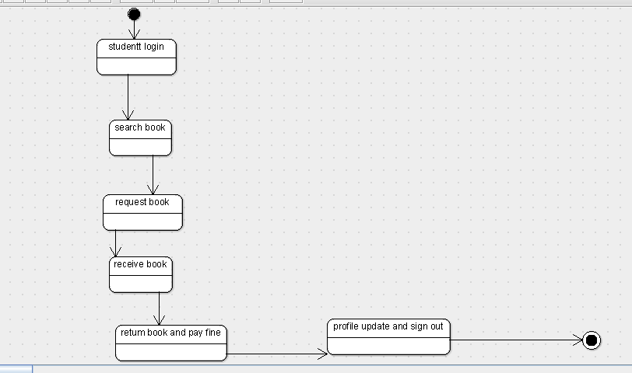

COMPONENT DIAGRAM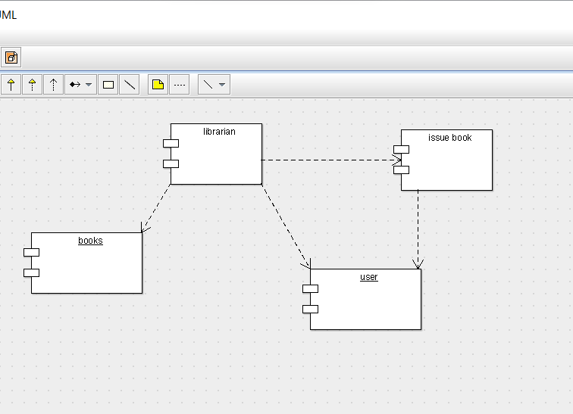

DEPLOYMENT DIAGRAM

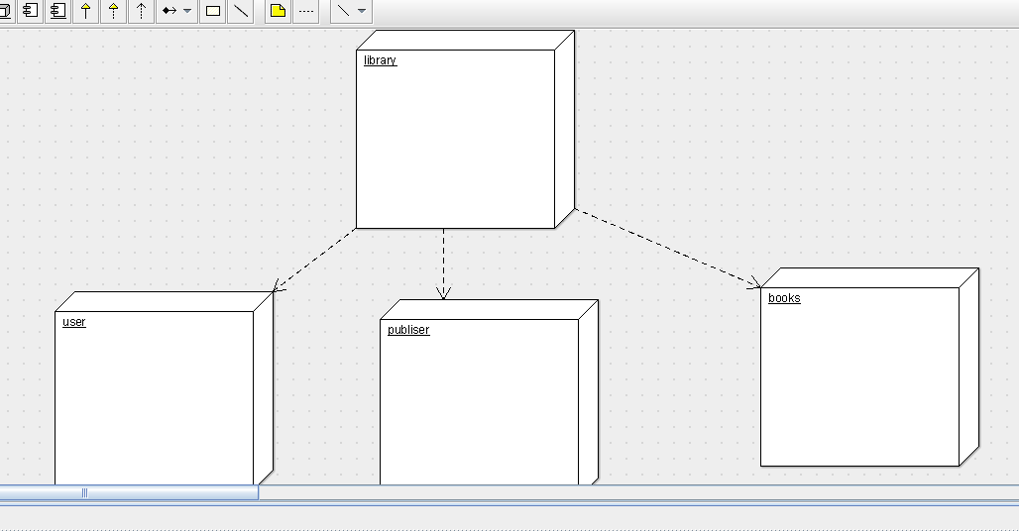

PACKAGE DIAGRAM